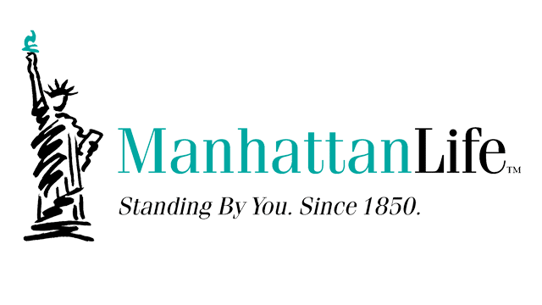

- 2020: Manhattan Life celebrated their 170th year in business.

- One of the largest and most solvent health insurance companies, with over $3 billion in assets and operating in almost every state and Puerto Rico.

- Manhattan Life has the strongest surplus ratio, far exceeding the 25 largest health & accident insurance companies in America.

- Manhattan Life’s “Affordable Choice” plans are the best value in America, with $5 million of comprehensive coverage and complete freedom to choose any doctor or hospital in the US.

- Manhattan Life is the reason why America’s oldest & most trusted form of health insurance is back and here to stay. Won unanimous decision in DC circuit court 7/1/2016 against Obama’s HHS (Health & Human Services dept.)

